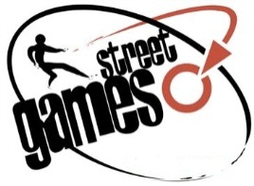

StreetGames Network –Organisation Information

Please complete this document if your organisation is interested in joining the StreetGames Network.
StreetGames would like to support your organisation’s vision to increase and improve the doorstep sport offer to disadvantaged young people. This form helps us to understand how best we as an organisation can support you
StreetGames will contact you using the information below.

Organisation Name:

Nominated Contact:
E-mail Address:

Telephone/Mobile Contact Numbers:
Postal Address :
(Please include postcode)

What is your experience of delivering youth community sport in areas of deprivation? If you are not delivering youth community sport at present, what are your plans for doing so?
Why does your organisation want to join the StreetGames network? What is the focus of your organisation?
StreetGames has a range of programmes and services that can support your organisation to develop your ‘Doorstep Sport’ offer to young people. Please see the StreetGames website (www.streetgames.org) for information about these programmes.
Please mark below which programme/s you are interested in benefitting from or finding out more about.
Please mark below which programmes you are interested in benefitting from or finding out more about.
Doorstep Sport Club Programme |  | Us Girls
Co-operative StreetGames Young Volunteer Programme |  | StreetGames Training Academy
StreetGames Events and Festivals |  | Knowledge and Research
Please explain why and how your organisation will benefit from your selections above

- Please return by email to doorstepclubeoi@streetgames.org or print and complete then send to StreetGames, Unit G3 Barton Hall Estate, Hardy Street, Eccles, Manchester, M30 7NB.

