EVENT CHECK LIST


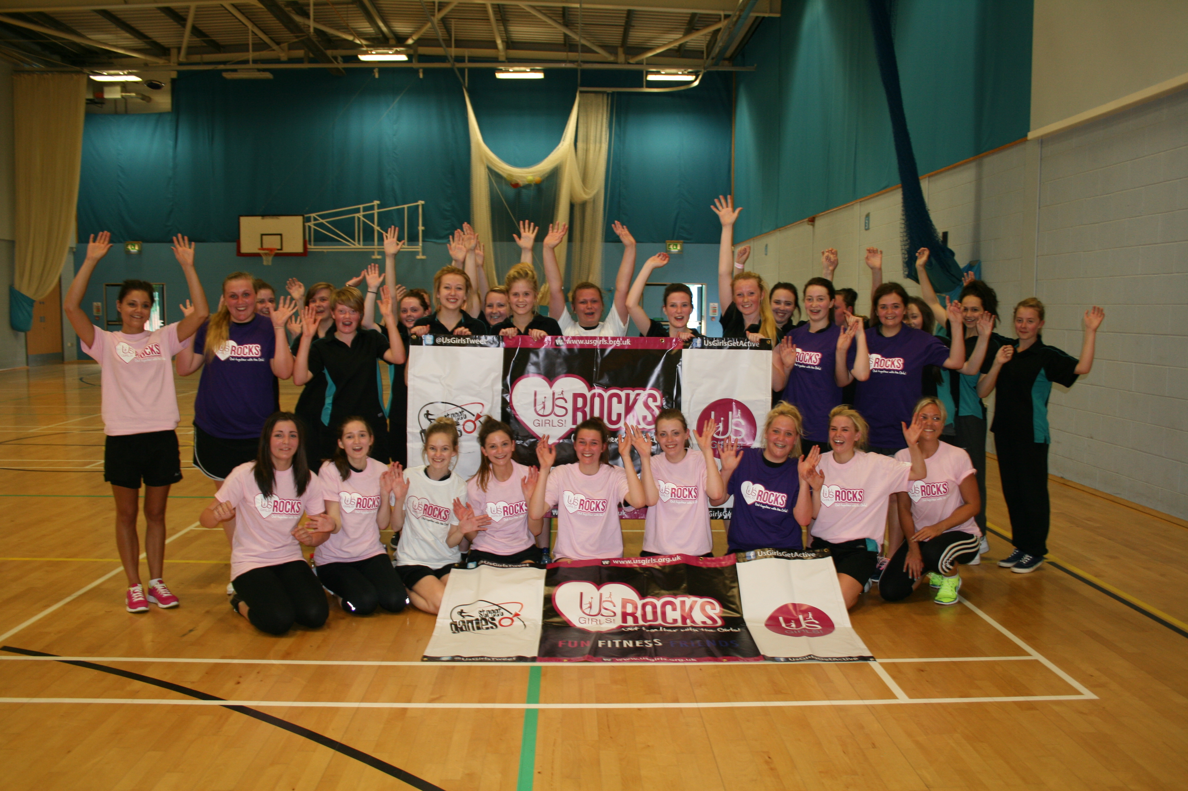

THINGS TO ACTION | ACTION STARTED | ACTION COMPLETED | ACTION BY | COMMENTS
 | (Date) | (Date) | (Name)
PRE EVENT
Accommodation
Accountant
Advertising
Backdrop
Budget
Catering
Chairs & Tables
Changing
Communications
Contracts
Date
Delivery Staff
Display Boards
Entries
Equipment
Event Management
Facilities
Fencing & Barriers
Finances
Funding
Help Line
Local Authority
Marketing & PR
Medical Room
Office
Office Equipment
Parking
Press
Prizes, Medals, Trophies & Certificates
Programme
Seating
Security
Security Room
Set Up
Signage
Sound System
Sponsors
Staff
Staging
Storage
Ticket Printing
Tickets
Toilets
Transport
Uniforms
Vendors
Venue
Videography
VIP’s / Celebrities
Volunteers
THINGS TO ACTION | ACTION STARTED | ACTION COMPLETED | ACTION BY | COMMENTS
 | (Date) | (Date) | (Name)
ON THE DAY
‘Special’ Performance
Backdrop
Catering
Ceremonies
Chairs & Tables
Changing
Communications
Competition Area
Delivery Staff
Display Boards
Entries
Equipment
Event Management
Facilities
Fencing & Barriers
Floor Tape
Interviews
IT Equipment
Judges / Referees
Lost Property
Master of Ceremonies (MC)
Medical Room
Medical Support
Office
Office Equipment
Officials
Parking
Photography
Press
Prizes, Medals, Trophies & Certificates
Programme
Registration
Seating
Security
Security Room
Set Up
Signage
Sound System
Staff
Staging
Take Down
Ticket Office
Tickets
Toilets
Uniforms
Vendors
Videography
VIP Liaison
VIP’s / Celebrities
Volunteers
Warm-up Area

THINGS TO ACTION | ACTION STARTED | ACTION COMPLETED | ACTION BY | COMMENTS
 | (Date) | (Date) | (Name)
POST EVENT
Debrief
Press
Reports
Thank You Letters
VIP’s / Celebrities

