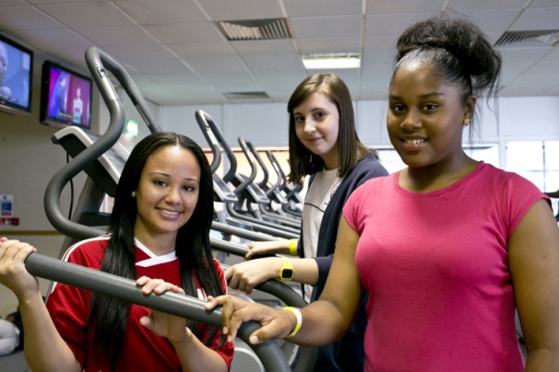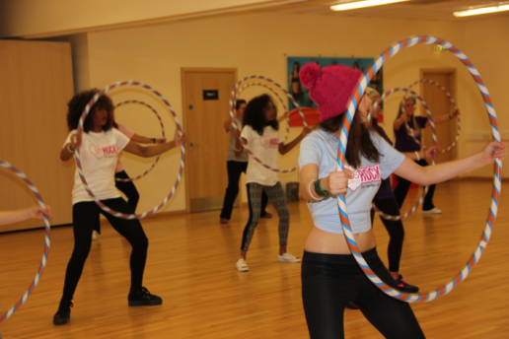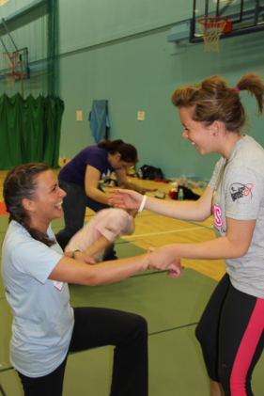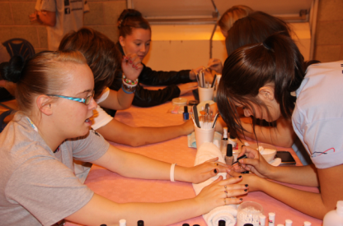

Join in at XXXXX Community Centre Tuesdays at 8pm!

facebook.com/xxxxxxxx

@UsGirlsTweet

Email contact details xxxxxx | phone number xxxxxxx

INSERT BODY TEXT insert body text, insert body text, insert body text, insert body text, insert body text, insert body text, insert body text

• body text body text

• insert body text

• body text body

Us Girls Alive