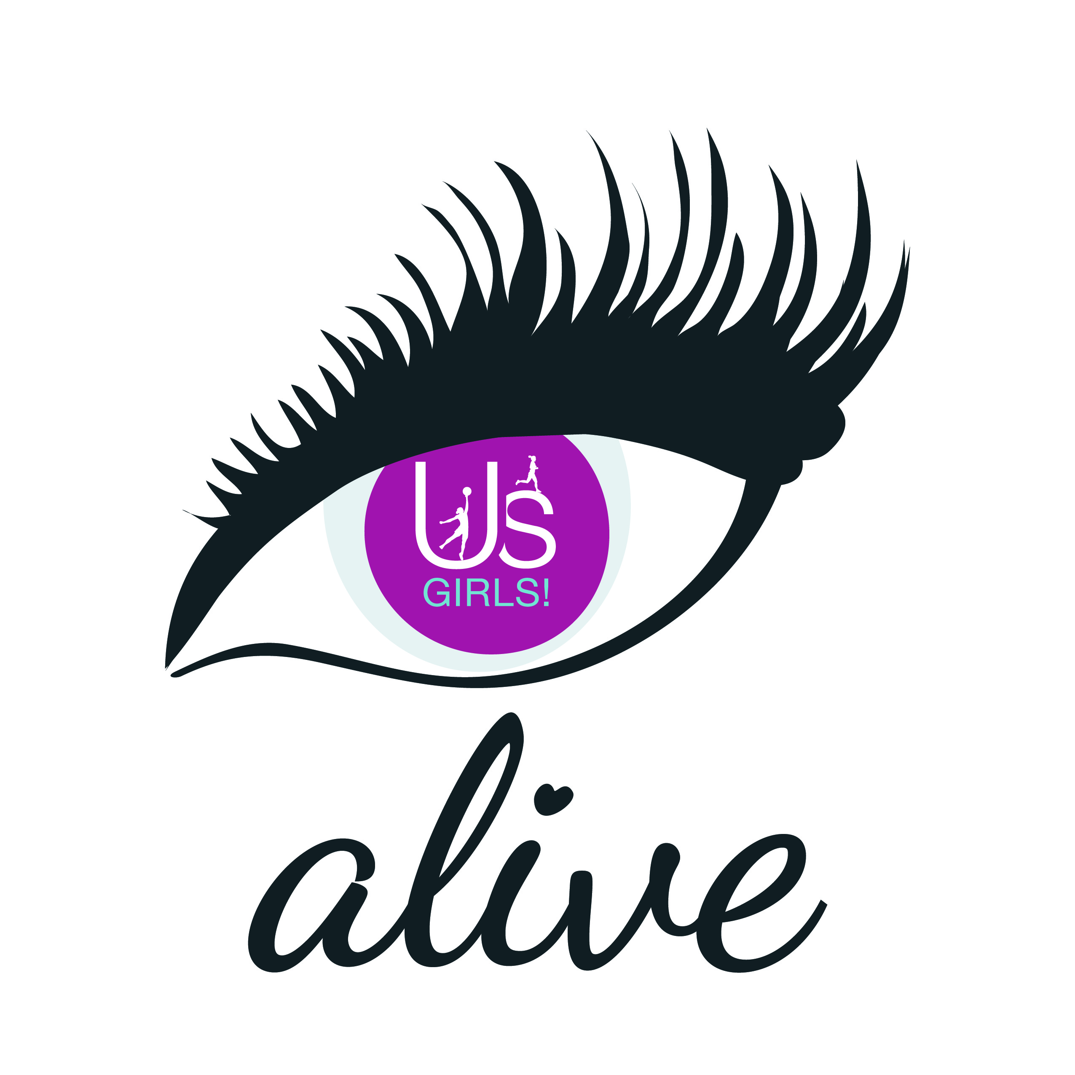
Us Girls Alive: Shared Learning Portal

We would love to hear more about how you have been getting on, anything you have learnt, what you have observed and any relevant information or feedback you would like to share with the Alive network.
To feature in our shared learning portal, just complete the boxes below and return to lian.lawrence@streetgames.org and it will be uploaded to the Us Girls Alive dedicated web page.
Project Name
Project Theme
(e.g ‘Engaging Young Girls in StreetDance’)
Location of Project
(venue and area)
Project Partners
(Who did you worked with?)
Introduction / Background / What you did?
Describe what activity has occurred and how it worked, what was delivered, where, how often etc. How many people were involved including participants, volunteers etc.
Impact / The difference it has made
This could include the difference it has made to the participants (most important), the difference it has made to the local area, the sport/NGB, to other partners etc.
Key success factors / Why it worked?
Think about style, place, price, time, staffing/personnel, equipment/kit/clothing, partnerships etc. What were the ingredients to success?
Quotes
Please provide quotes or comments from participants, project leaders and partners.
Images
Please provide photos and relevant logos to accompany this case study. List the images you have attached.
Project Contact
Please provide the project lead’s contact details so people can get in touch; name, email address, phone number and website.

