Us Girls Merchandise
Please see below Active Women merchandise. Please select which items you would like to order with details of the sizes and the quantities you require.
Delivery Costs:
A delivery charge of approximately £15 will be added onto your order. For large orders please allow for higher delivery charges.
Please return you orders to lian.lawrence@streetgames.org
Orders:
Project Name | Contact Name | Contact Details

Promotional Cotton Shopping Bag – Colour: White including Us Girls Logo £2.00 each.
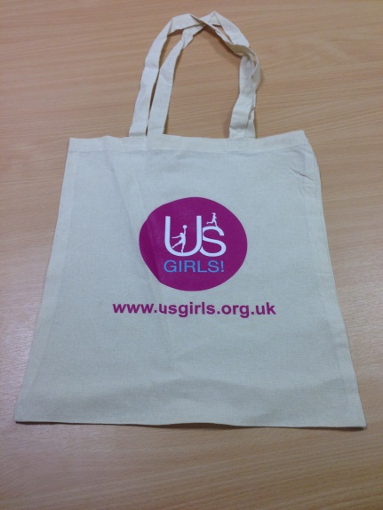

Promotional Cotton Shopping Bag
Quantity

Ladies Fit Tee – Includes Us Girls logo on the front. Available in sizes: Small, Medium, Large and X-Large. Colour range: Purple, Black and Pink. £3.25
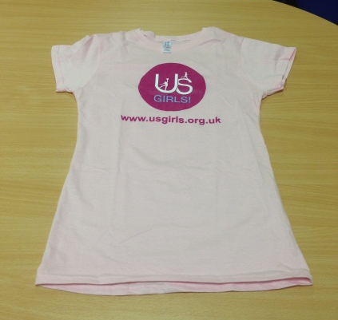
Ladies Fit Tee
Size | Colour | Quantity

Unisex T-Shirt – To include Us Girls logo on front. Available in sizes: Small, Medium, Large and X-Large. Colour range: Purple, Black and Pink. £3.25

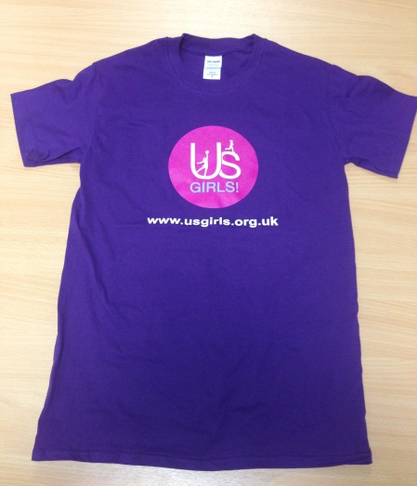
Unisex T-Shirt

Size | Colour | Quantity
Hooded Sweatshirt – To include Us Girls logo on front. Available in sizes: Small, Medium, Large and X-Large. Colour range: Purple, Black and Pink. £10.60

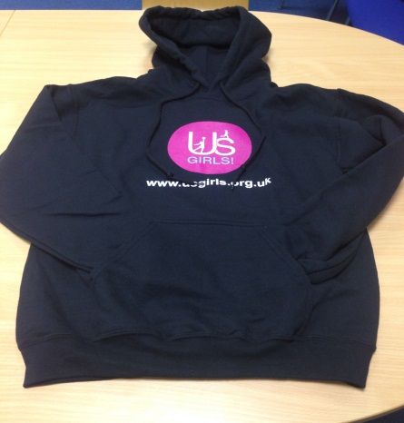

Hooded Sweatshirt
Size | Colour | Quantity

Waterproof Jackets – To include Us Girls logo on front. Available sizes XS, Small, Medium, Large and XL. Colour range: Ice Light Blue, Dark Blue and Black £28.00

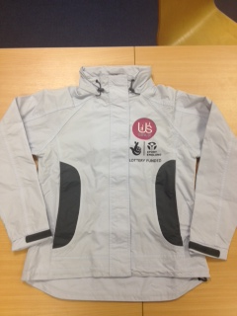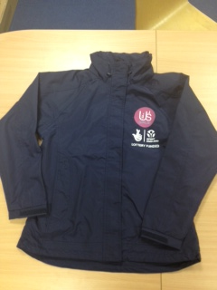
Waterproof Jackets
Size | Colour | Quantity
500ml Finger Grip Sports Bottle – White bottles to include Us Girls logo. Ergonomically designed, BPA Free sports bottle with dimpled finger grip to prevent slipping and a secure screw top lid to hold 500ml of liquid. £2.00 each.
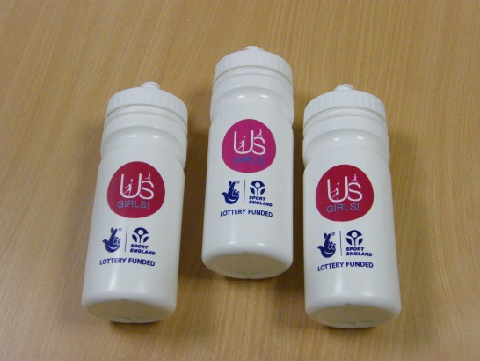

500ml Finger Grip Sports Bottle
Quantity

Drawstring Cotton Backpacks – With Us Girls logo printed on the front – Navy blue only. £2.70 each.
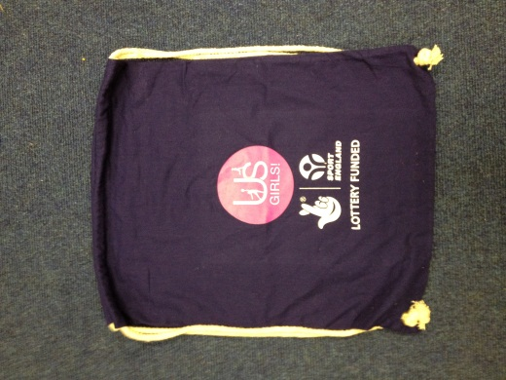
Drawstring Cotton Backpacks
Quantity
Us Girls Pens – White pens with purple detail, complete with the Us Girls logo and website address £0.95 each.
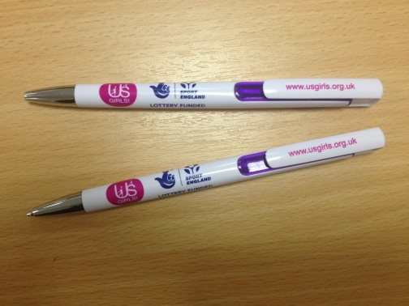
Us Girls Pens
Quantity

Us Girls 2 in 1 Nail File – White nail file complete with the Us Girls logo printed on the front – White only. £1.30 each.
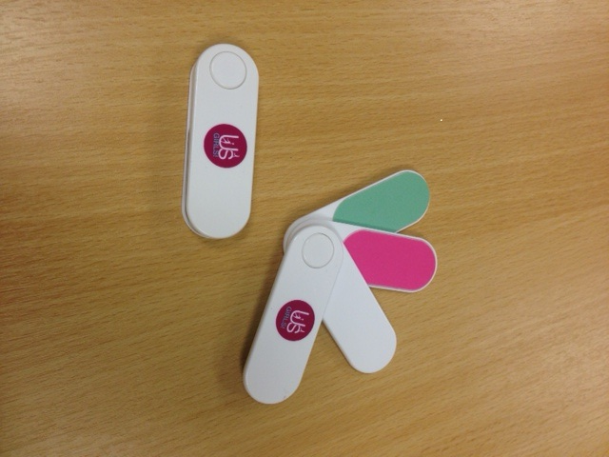

Us Girls 2 in 1 Nail File
Quantity
Us Girls Compact Hairbrush and Mirror - White compact pop out hairbrush with mirror complete with the Us Girls logo printed on the front – White only. £1.30 each.
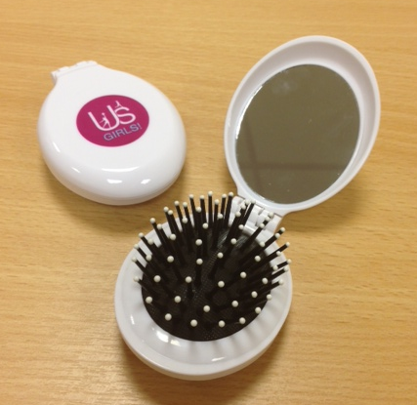

Us Girls Compact Hairbrush and Mirror
Quantity

Outdoor Banner – Digital printing, 2 x 1 metre banner. Please note, additional logos can be added but may increase the price. Approximate cost: £45

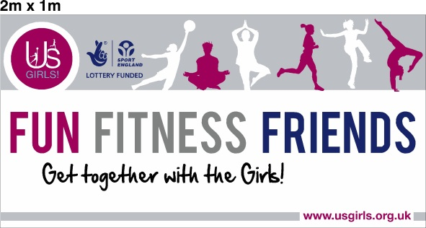

Outdoor Banner
Text | Quantity
Please supply further information on additional
logos if required.

Outdoor Us Girls Rocks Banner – Digital printing, 2 x 1 metre banner. Cost £45

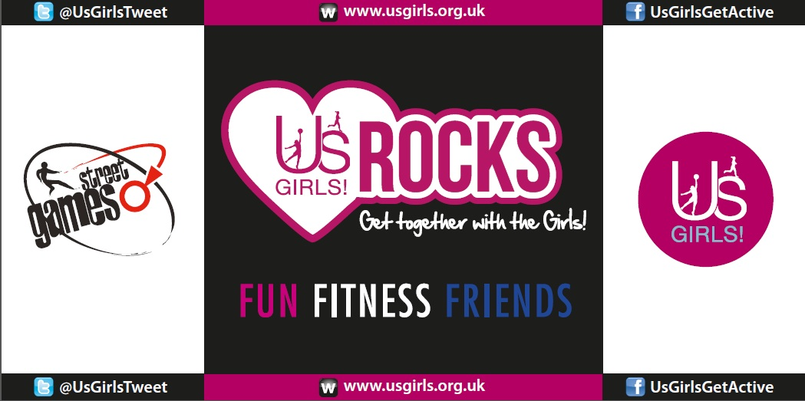
Outdoor Banner
Quantity

Pull Up Banner – Stand free pull up banner including stand. Please note, additional logos can be added but may increase the price. Approximate Cost: £90
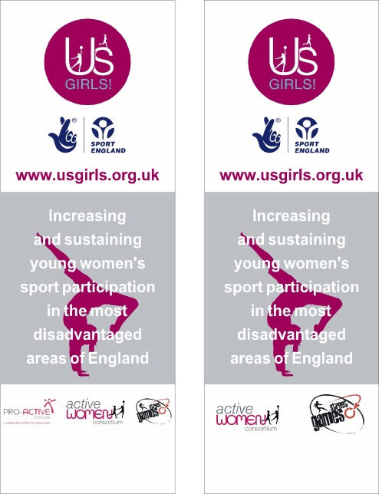
Pull Up Banner
Quantity
Please supply further information on additional logos if required.

Please return order form to lian.lawrence@streetgames.org or call 0845 1300 849 for further enquiries.

